Advanced Functions 12 – CONNECTschool Comparison Chart
McGraw-Hill Education
Feature | Current Version of CONNECTschool | New Version of CONNECTschool
My Courses Page | 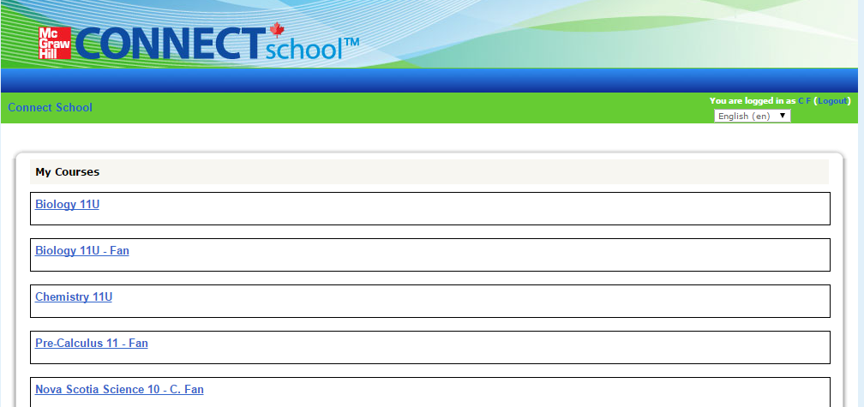 | 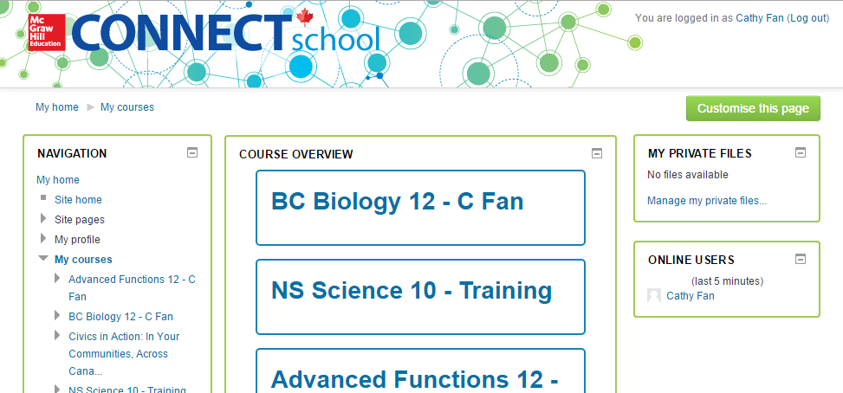  WHAT’S NEW:  - The My Courses page appears after you login, and lists all of your CONNECTschool courses. The layout of this page has been streamlined, making it easier to find your course.
Course Homepage: Main Page | 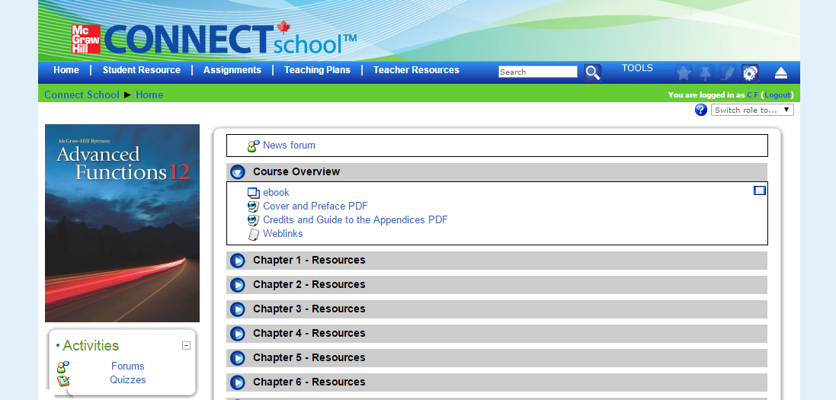 | 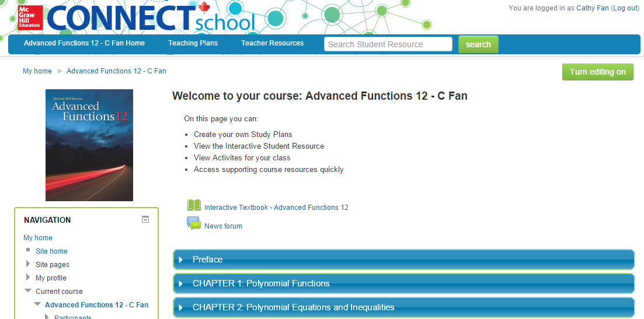  WHAT’S NEW:  - The Course Homepage has been streamlined. There is now a description of what you can do and access from the Course Homepage.  - All of the digital resources for the course (including the Interactive Textbook) are available in one-click using the links in the collapsible menus.  - Customized editing options are now available on the Course Homepage using the “Customize Your Course” button (see “Adding an Activity or Resource” below for more details).  Examples include:  - Adding Activities (e.g., Assignments, Quizzes, Chats, Forums)  - Adding Resources (e.g., Files, Links, HTML pages, Wikis)
Course Homepage: Sections |  | 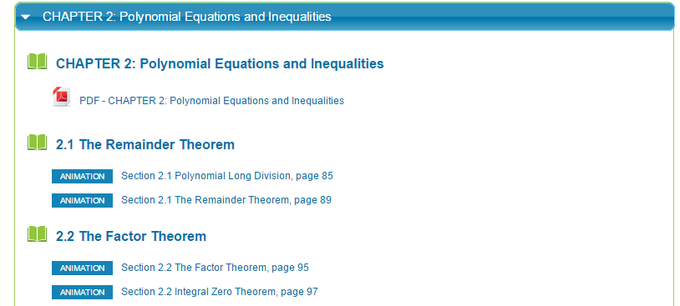  WHAT’S NEW:  - The collapsible sections now include the names of the chapters.  - Each digital resource is organized by section. You can access each resource by clicking title. If you click the page number in the link, you will be directed to that page in the Interactive Textbook.
Course Homepage:  Panels/Blocks | 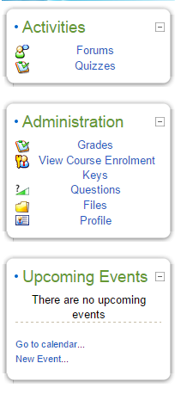 | 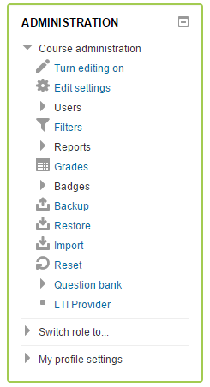  WHAT’S NEW:  - The Administration block now contains more features, including “Reports”, which allows teachers to monitor their students’ online activity.
Student Resource/  Interactive Textbook | 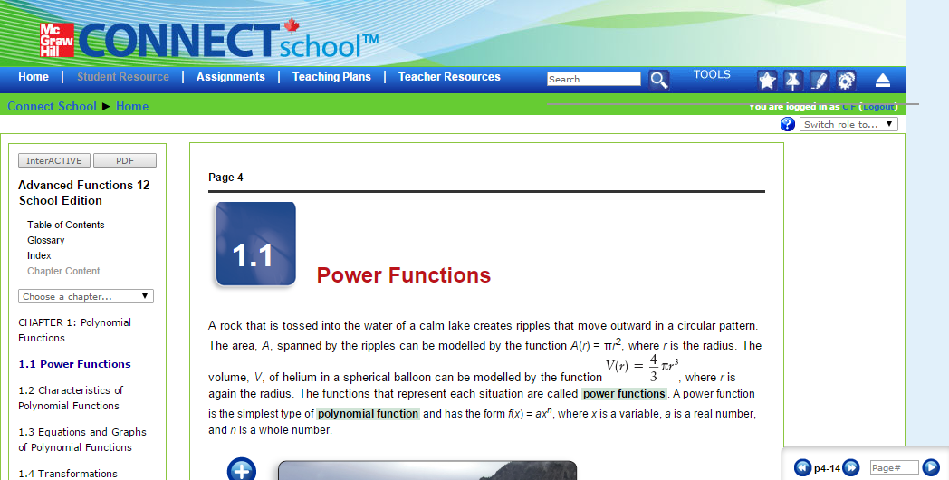 | 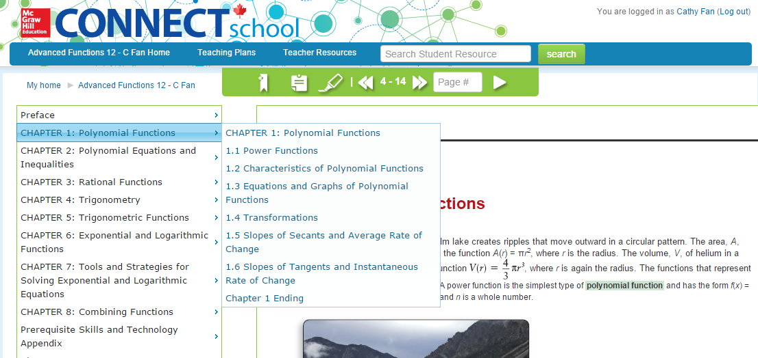  WHAT’S NEW:  - The navigation of the Interactive Textbook has been improved. Users can now easily navigate to specific sections of the textbook using the dynamic Table of Contents.  - Users can jump to specific pages by entering a page number in the “Page #” field of the Toolbar.  - The Interactive Textbook no longer has a “PDF” button. To view and download PDFs of the textbook, see below (“Textbook: Downloadable PDFs”).
Student Resource/  Interactive Textbook: Answers | 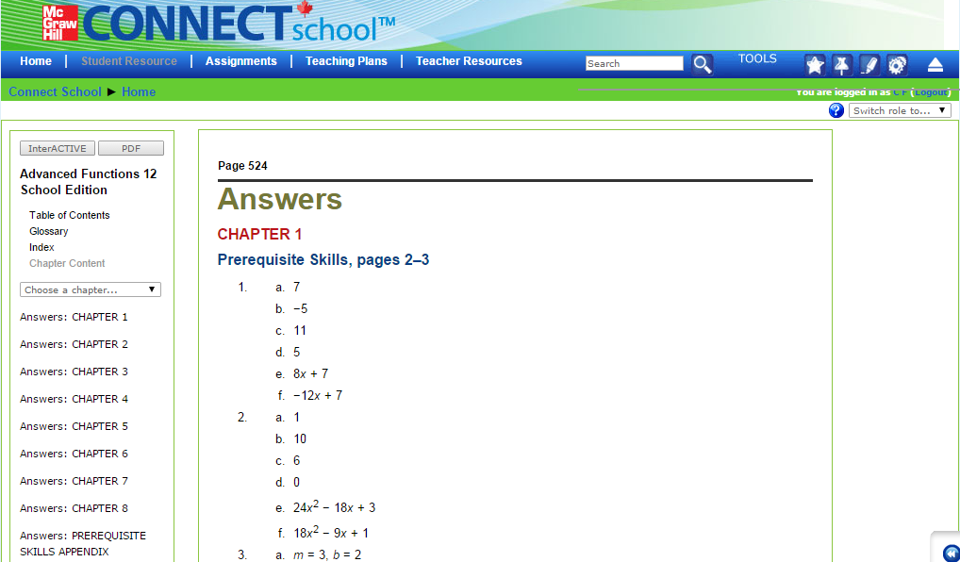 | 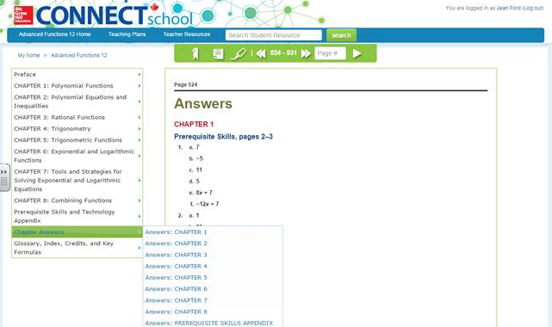  WHAT’S NEW:  - Answers to questions in the textbook can now be accessed by Chapter using the dynamic Table of Contents.

Student Resource: Downloadable PDFs |  | WHAT’S NEW:  - Downloadable PDFs of the textbook can be found in each Chapter menu on the Course Homepage.
Teacher Resources | 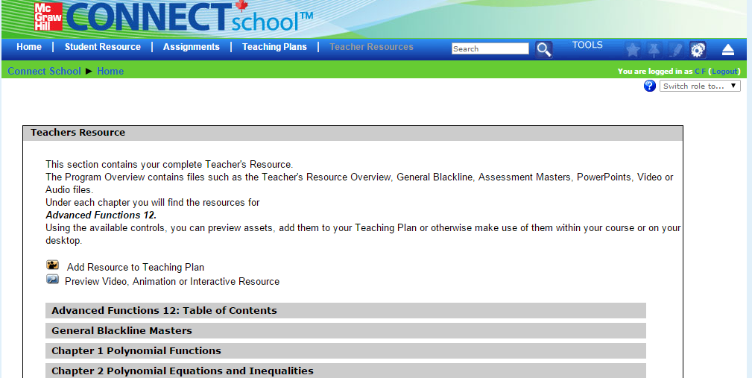 | 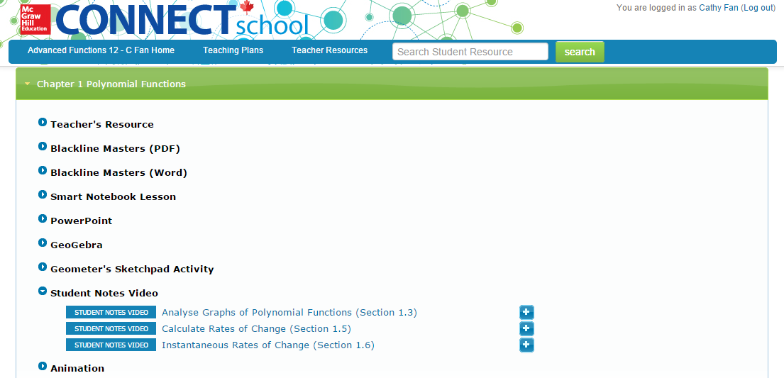  WHAT’S NEW:  - The Teacher Resources section has been reorganized to make finding digital assets easier.  - All of the resources are now grouped by type (e.g., BLMs, Videos, Interactive Activities, etc.) in collapsible menus.
Teaching Plans | 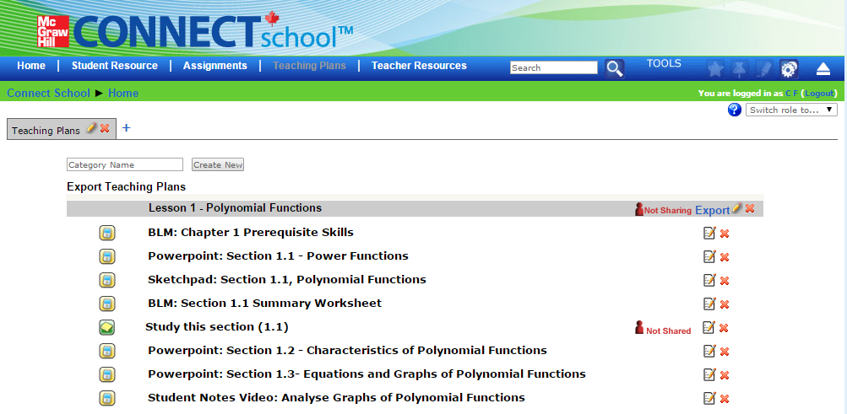 | 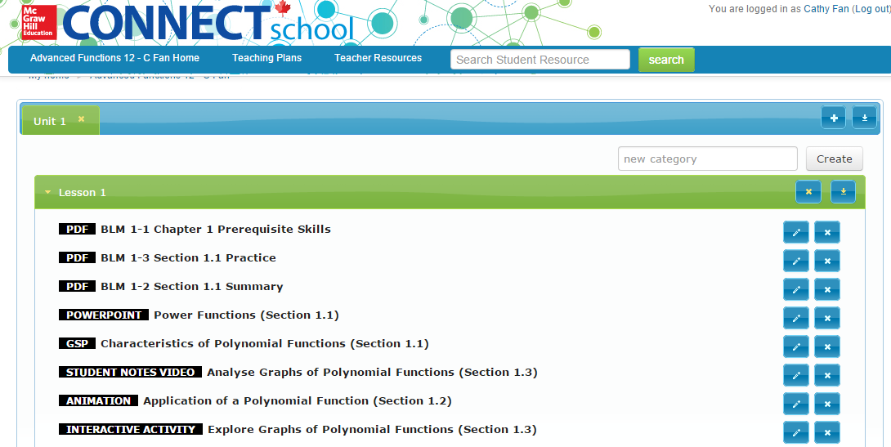  WHAT’S NEW:  - The Teaching Plans section has been streamlined to make it easier to add and organize resources for lessons.  - Each Teaching Plan item has a label that identifies the type of resource (e.g., PDF, Interactive Activity, Image)
Assignments, Quizzes, and Other Resources/  Adding an Activity or Resource | 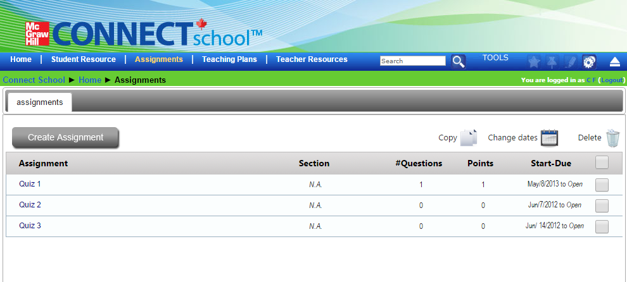 | 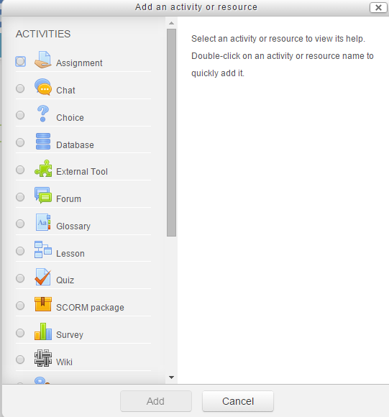  WHAT’S NEW:  - You can add an activity or resource to the Course Homepage by clicking the “Customize Your Course” button.  - The Assignment Builder has been replaced with built-in Moodle activities, such as “Assignment” and “Quiz”.  - Additional Moodle activities and resources can also be added and customized. These include Chats, Forums, Feedback, Wikis, Workshops (Student Group Work), Files, and Links.

